**St Philip’s Catholic Primary School**



Behaviour and Discipline Policy

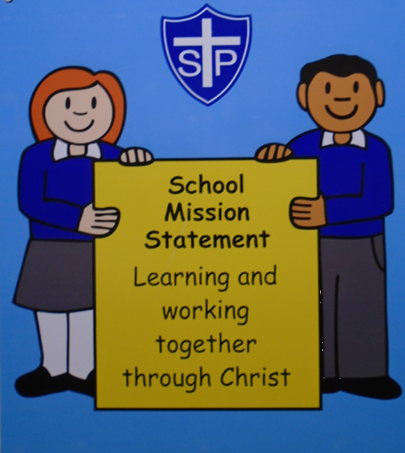

Please also see our Safeguarding, Online Safety Policies, Suspension and Exclusions Policy and SEND policy

## **St Philip’s mission statement is;**

***Learning and working together through Christ***

## **Statement of intent**

**St Philip’s Catholic Primary School** believes that, in order to facilitate teaching and learning, acceptable behaviour must be demonstrated in all aspects of school life to respect the dignity of each person as people of God.

The local governing body and staff at our school are committed to:

* A whole -school approach to maintaining high standards of behaviour that reflect the values of our school.
* Creating a safe, positive and nurturing learning environment to promote positive behaviour and discipline with clear guidelines.
* Building self-esteem, self –discipline and positive relationships based on mutual respect and the example of Jesus Christ.
* Promoting respect and ensuring that for all pupils and adults positive relationships are based on mutual respect.
* To develop the whole child intellectually, physically, emotionally, socially, morally and spiritually.
* Define what we consider to be unacceptable behaviour, including bullying and discrimination.

|  |  |  |  |
| --- | --- | --- | --- |
| Signed by: | | | |
| **Mrs C Hinton** | Principal | Date: |  |
| **Mrs S Godber** | Chair of governors | Date: |  |

# Guidance documents

Guidance documents to support Behaviour in Schools 2024

|  |  |
| --- | --- |
| Alternative Provision | Alternative Provision: Statutory guidance for local authorities, as well as headteachers and governing bodies of settings providing alternative provision  [Alternative provision - GOV.UK](https://www.gov.uk/government/publications/alternative-provision)  Education for children with health needs who cannot attend school  [Education for children with health needs who cannot attend school - GOV.UK](https://www.gov.uk/government/publications/education-for-children-with-health-needs-who-cannot-attend-school) |
| Children with Special Educational Needs and Disabilities  Equal Opportunities | SEND Code of Practice: 0 to 25 years [SEND code of practice: 0 to 25 years - GOV.UK](https://www.gov.uk/government/publications/send-code-of-practice-0-to-25) and School policy: [St Philip's Catholic Primary School - Policies and Documents](https://www.st-philips.sandwell.sch.uk/Page/Detail/policies-and-documents-1)  Children with special educational needs and disabilities (SEND): Overview [Children with special educational needs and disabilities (SEND): Overview - GOV.UK](https://www.gov.uk/children-with-special-educational-needs#:~:text=Special%20educational%20needs%20and%20disabilities%20(%20SEND%20)%20can%20affect%20a%20child,example%20because%20they%20have%20dyslexia)  Equal Opportunities & Equality and Diversity Statement  [St Philip's Catholic Primary School - Policies and Documents](https://www.st-philips.sandwell.sch.uk/Page/Detail/policies-and-documents-1) |
| Departmental Advice on safeguarding and child protection  Departmental Advice on Promoting the education of looked-after and previously looked-after children | Keeping children safe in education [Keeping children safe in education - GOV.UK](https://www.gov.uk/government/publications/keeping-children-safe-in-education--2)  Children Missing Education [Children missing education - GOV.UK](https://www.gov.uk/government/publications/children-missing-education)  Working Together to Safeguard Children [Working together to safeguard children - GOV.UK](https://www.gov.uk/government/publications/working-together-to-safeguard-children--2)  Promoting the welfare of looked-after and previously looked-after children [Promoting the education of looked-after children and previously looked-after children](https://assets.publishing.service.gov.uk/media/5a9015d4e5274a5e67567fbe/Promoting_the_education_of_looked-after_children_and_previously_looked-after_children.pdf)  Adverse Childhood Experiences training and resources (funded by the Home Office) [Routine enquiry about adverse childhood experiences: implementation pack evaluation - GOV.UK](https://www.gov.uk/government/publications/routine-enquiry-about-adverse-childhood-experiences-implementation-pack-evaluation)  The designated teacher for looked-after and previously looked- after children |
| Sharing and publishing information | School to school service: how to transfer information [School to school (S2S) guide for schools](https://assets.publishing.service.gov.uk/media/5d3abd0140f0b604de59fe0a/DfE_S2S_Guide_Schools_July_2019.pdf)  What maintained schools must publish online [What maintained schools must or should publish online - GOV.UK](https://www.gov.uk/guidance/what-maintained-schools-must-publish-online)  What academies, free schools and colleges should publish online [What academies and further education colleges must or should publish online - GOV.UK](https://www.gov.uk/guidance/what-academies-free-schools-and-colleges-should-publish-online) |

Legislation and Guidance

This policy is based on advice and statutory guidance from the Department for

Education:

Behaviour in Schools (February 2024) [Behaviour in schools - GOV.UK](https://www.gov.uk/government/publications/behaviour-in-schools--2)

Use of reasonable force (July 2013) [Use of reasonable force in schools - GOV.UK](https://www.gov.uk/government/publications/use-of-reasonable-force-in-schools)

School Suspensions and Permanent Exclusions [School suspensions and permanent exclusions - GOV.UK](https://www.gov.uk/government/publications/school-exclusion#%3A%7E%3Atext%3DSchools%20and%20colleges%20must%20continue%2Cheadteachers)

Searching, screening and confiscation (July 2022) [Searching, screening and confiscation in schools - GOV.UK](https://www.gov.uk/government/publications/searching-screening-and-confiscation)

Keeping Children Safe in Education (September 2024) [Keeping children safe in education - GOV.UK](https://www.gov.uk/government/publications/keeping-children-safe-in-education--2)

SEND , code of practice 0-25 years [SEND code of practice: 0 to 25 years - GOV.UK](https://www.gov.uk/government/publications/send-code-of-practice-0-to-25)

Supporting pupils at school with medical conditions [Supporting pupils with medical conditions at school - GOV.UK](https://www.gov.uk/government/publications/supporting-pupils-at-school-with-medical-conditions--3)

The Equality Act 2010 Special Educational Needs and Disability Code of Practice (2015) [Equality Act 2010: advice for schools - GOV.UK](https://www.gov.uk/government/publications/equality-act-2010-advice-for-schools)

Working Together to Safeguard Children (December 2023) [Working together to safeguard children - GOV.UK](https://www.gov.uk/government/publications/working-together-to-safeguard-children--2)

# Roles and Responsibilities

The **Principal** is responsible for:

* Establishing the standard of behaviour expected by pupils to promote a calm and safe ethos at the school.
* Determining the school rules and any appropriate disciplinary sanctions where school rules and the school’s mission statement are not adhered to.
* Ensuring that staff deal with poor behaviour effectively and that all staff understand the school’s behaviour culture and vision.
* The day-to-day implementation of this policy and that the statement is adhered too.
* To promote positive attitudes and motivation to ensure that behaviour and attendance is of a high standard.
* Ensuring that appropriate external teams are effectively involved and that training is offered to staff to follow the policy .
* Ensuring that types of behaviour data is reviewed regularly , to ensure that groups of pupils are NOT disproportionately impacted by this policy.

**All members of staff, volunteers and support staff** are responsible for:

* To provide a calm, secure learning environment to promotes a positive atmosphere .
* To create a learning environment which encourages and reinforces good behaviour with positive classroom management and organisation.
* To ensure that the established school rules are implemented and that the rewards and sanctions are known by staff, children and parents.
* To encourage the development of independence and the fostering of self discipline, cooperation, tolerance and respect for others.
* To provide a positive learning environment that promotes and engages teaching and learning through adaptive teaching to meet the needs of all pupils.
* To teach the Catholic School’s Pupil Profile alongside the Catholic Social Teaching principles through the whole school curriculum to promote respect and tolerance.
* Adhering to this policy and ensuring that all pupils do too.

**Pupils are responsible for:**

Living out the school mission statement through their own behaviour in school by :

* By following the school rules.
* By knowing and understanding what acceptable behaviour is.
* By knowing and understanding what unacceptable behaviour is.
* By walking sensibly, politely and quietly in and around school.
* By using their manners to all that we meet .
* By using the go forth messages from our Gospel assemblies to demonstrate good behaviour and respect for others.

**Parents are responsible for**:

* + Parents support the behaviour of their child(ren) inside and outside of school in line with this policy and our home/ school agreement.
  + To work alongside the school to address any factors that may impact upon a child’s behaviour.
  + Support the school in the implementation of the behaviour and discipline policy.
  + supporting behaviour expectations of the school whilst within the school grounds.
  + To ensure their child(ren) attend school regularly and arrive on time each day.
  + To maintain good communication with home and school.
  + To adhere to GDPR and the online safety policy by showing respectful behaviour at school events and respecting the privacy of children not taking any videos or photographs.
  + Parents and school to work together to address negative behaviour through attending meetings.
  + Not using threatening, abusive, intimidating, insulting and defamatory language on the playground that isn’t reflective of the school ethos.

# Our school expectations at St Philip’s Catholic Primary School

At St Philip’s Catholic Primary School we have worked together to develop simple guidelines about behaviour, discipline, rewards and when necessary, sanctions to enable everyone to work and play successfully, safely and happily to live out our school values .We have high expectations of pupil’s behaviour in school and ask that the children follow five school rules:

All classes will have the same **rules**:

* Call everyone by their given name
* We listen to the person who is speaking
* Keep your hands and feet to yourself
* Walk everywhere in and around school
* Take care of, and have respect for, everyone’s belongings

These rules should be used as positive statements when reminding pupils of them for example ‘***well done for walking sensibly’ or ‘remember that we walk around school’.***

# St. Philip’s Way

In order for pupils to display positive behaviour, all staff are committed to implementing the St. Philip’s behaviour curriculum to teach pupils how to demonstrate all desirable behaviours in every aspect of school life.

This ensures that through explicit teaching, being a positive role model and consistent reinforcement all pupils know and understand what is appropriate to do in different situations.

**In our school positive behaviour is :**

* Walking in and around school grounds
* Consistent good manners and calling everyone by their given name
* Willingness to help each other learn / or helping an adult
* Having respect and consideration for adults and pupils
* Consistent effort for work to achieve in class
* Following instructions when first given to a pupil
* Ability to be honest and forgive and become reconciled after quarrels or upsets
* Sharing and caring relationships
* Displaying positive learning behaviours

**Misbehaviour is defined as:**

* Disruption in lessons, in corridors between lessons and at break and lunchtimes
* Non completion of class work & refusal to work in class and with any given adult
* Hurting a friend with unkind words, hands or feet
* Poor attitude or responses to adults and peers
* Disrepectful behaviour towards peers and adults
* Not following instructions by adults.
* Poor attitude to work and classroom expectations whereby the learning of other pupils is affected.
* Leaving the classroom or safe environment without permission
* Swearing
* Throwing objects in class or around school that causes danger to others

**Serious misbehaviour is defined as:**

For the purpose of this policy, the school defines “**serious unacceptable behaviou**r” as any behaviour which may cause harm to oneself or others, damage the reputation of the school within the wider community, and/or any illegal behaviour, including, but not limited to, the following:

* + **Bullying** –**(child on child)** a type of harassment which involves criticism, personal abuse or persistent actions which humiliate, intimidate, frighten or demean the individual
  + **Discriminatory bullying** – not giving equal respect to an individual on the basis of disability, gender, race, religion, age, sexuality.
  + **Racist, sexist, homophobic or discriminatory behaviour**
  + **Cyberbullying** – the use of electronic communication to bully a person, typically by sending messages of an intimidating or threatening nature
  + **Prejudice-based bullying -** when bullying behaviour is motivated by prejudice based on an individual’s actual or perceived identity; it can be based on characteristics unique to a child or young person’s identity or circumstance.
  + **Sexual Harassment** –**(child on child)** behaviour towards others which is unwanted, offensive and affects the dignity of the individual or group of individuals or sexual assault against another pupil such as ; sexual jokes , names or comments.
  + **Sexual Violence - (child on child)** such as rape, assault by penetration, or sexual assault (intentional sexual touching without consent)
  + **Online sexual harassment**, **(child on child)** such as unwanted sexual comments and messages (including on social media), sharing of nude or semi-nude images and/or videos, or sharing of unwanted explicit content
  + **Upskirting** – which involves taking a picture under someone’s clothing without them knowing; this is usually with the intention of viewing their genitals or buttocks for sexual gratification, or to cause the victim humiliation, distress or alarm. Upskirting is a criminal offence and anyone of any gender can be a victim.
* **Initiation** / hazing type violence and rituals.
  + **Vexatious behaviour** – deliberately acting in a manner so as to cause annoyance or irritation
  + Repeated breach of the school rules that affects the learning of others
  + Smoking /vaping
  + Refusing to comply with disciplinary sanctions
  + Theft
  + Malicious allegations
  + Vandalism
  + Physical assault of any kind towards another pupil, staff or visitors
  + Endangering the safety of themselves, other children and staff – carelessly or with intent
  + Possession of any **prohibited items (as per subsection (3) of Section 550ZA of the Education Act 1996:**
  + *Knives or weapons, alcohol, Illegal drugs, Stolen items, tobacco, cigarettes, vapes, fireworks Pornographic image*

**Bullying**

Bullying is defined as the repetitive, intentional hurting of one person or group by another person or group, where the relationship involves an imbalance of power. Bullying can be physical, verbal or psychological. It can happen face-to-face or online.

There are four key elements to this definition:

* hurtful
* repetition
* power imbalance
* intentional

Bullying behaviour can be:

* Physical – pushing, poking, kicking, hitting, biting, pinching etc.
* Verbal - name calling, sarcasm, spreading rumours, threats, teasing, belittling.
* Emotional – isolating others, tormenting, hiding books, threatening gestures, ridicule, humiliation, intimidating, excluding, manipulation and coercion.
* Sexual – unwanted physical contact, inappropriate touching, abusive comments, homophobic abuse, exposure to inappropriate films etc.
* Online /cyber – posting on social media, sharing photos, sending nasty text messages, social exclusion
* Indirect - Can include the exploitation of individuals.

**Promoting good behaviour**

To acknowledge good behaviour in our school we will use some of the following strategies;

* Dojo points
* Stamps and stickers
* Certificates
* Good work sent home / sharing success
* Celebration in assembly
* Classroom responsibility
* Attendance at out of school events / Cinema trip
* Class prizes & Principal / Vice -Principal rewards.

At the end of every half term the pupils who have achieved 150 dojos receive a special reward to celebrate their excellent behaviour and achievements for the half term , for e.g tea party with SLT , extra playtime.

**Responding to behaviour**

**Consequences**

On the occasions where the desired behaviour is not followed, the following consequences may be implemented by members of staff:

* Verbal/visual warning to encourage the child to change and improve their behaviour (up to 3 warnings)
* Lost dojos.
* A reflection time within the classroom given (re-positioning)
* Behaviour reflection sheet to be completed with an adult at breaktime/ lunchtimes.
* Loss of breaktimes/ lunchtime
* Referring pupil to a senior member of staff
* De-escalation techniques can be used to help prevent further behaviour issues arising, such as the use of emotional Coaching strategies and scripts
* Communication with parents about behaviour concerns
* Loss of privileges
* Record on Behaviour log on ARBOR
* Removal of the pupil from the classroom to another space.
* Agreement of a behaviour contract / reward charts
* If inappropriate behaviour continues – adaptive teaching measures are put into place to direct pupils to a designated activity with an adult to regulate their behaviour.
* Suspension
* Permanent exclusion, in the most serious of circumstances

# Adaptive teaching

To support our pupils to make positive choices, it may be necessary to put in place the following strategies;

* Designated place in the class line
* Pupil support plan
* Identification/reduction of triggers
* 1:1 teaching within areas of the curriculum
* Adaptive personal timetable
* Reduced timetable
* Involvement with external agencies
* Environment changes – working in another classroom / space to enable regulation time
* Regulation charts and reflections
* Fidget toys
* Ear defenders
* NOW/ NEXT
* Activity boxes
* Meet and greet

To support a pupil to access the curriculum and manage their own behaviour, the 5 point scale (appendices)will be introduced temporarily to support the emotional needs of a pupil.

# Removal from classrooms (Internal Suspension)

In response to serious or persistent breaches of this policy, the school may remove the pupil from the classroom for a limited time. Pupils who have been removed will continue to receive education under the supervision of a member of staff that is meaningful, but it may differ from the mainstream curriculum.

Removal is a serious sanction and will only be used in response to serious misbehaviour. Staff will only remove pupils from the classroom once other behavioural strategies have been attempted, unless the behaviour is so extreme as to warrant immediate removal.

Removal can be used to:

* Restore order if the pupil is being unreasonably disruptive
* Maintain the safety of all pupils
* Allow the pupil to continue their learning in a managed environment
* Allow the pupil to regain calm in a safe space

Pupils who have been removed from the classroom are supervised by a qualified member of staff and will be removed for a maximum of a school day.

Pupils will not be removed from classrooms for prolonged periods of time without the explicit agreement of a member of the Senior Leadership Team.

An incident log on Arbor will be completed to record what has happened and what the outcome was.

Pupils should be reintegrated into the classroom as soon as appropriate and safe to do so.

The school will consider what support is needed to help a pupil successfully reintegrate into the classroom and meet the expected standards of behaviour.

Parents will be informed verbally on the same day that their child is removed from the classroom.

The school will consider an alternative approach to behaviour management for pupils who are frequently removed from class, such as:

* Support and interventions from the school’s Pastoral Team
* Working together with parents
* Use of teaching assistants to provide targeted support
* Short term behaviour trackers
* Long term behaviour support plans
* Pupil support units
* Support from Inclusion Support

(Please see adaptive teaching methods above.)

**Risk Assessment**

* Where children pose a risk of danger/ harm to themselves , property or others , suspension, permanent exclusion, robust risk assessments are completed for the child to ensure the potential for behaviour not in keeping with school policy is reduced and as such reduce the risk of suspension or exclusion for the child.
* Risk assessments for children at risk of suspension or permanent exclusion are in keeping with any care plans/behaviour plans that the child may have to ensure consistency for the child.
* Risk assessments that are completed for children at risk of suspension or permanent exclusion are agreed and signed by parents and are shared with the child.
* Ensure that a date for a follow up review is set.

Suspension and permanent exclusions

The school can use suspension and permanent exclusion in response to serious incidents or in response to persistent poor behaviour, which has not improved following in-school sanctions and interventions.

The decision to suspend or exclude will be made by the Principal and only as a last resort.

When a Suspension is given

* Parents immediately contacted by SLT, informed of exclusion and asked to collect child immediately
* Pupil to be sent home for up to 5 days (Chair of Governors informed of 5-day exclusions)
* Parents to receive notification and advice by letter
* Work to be provided by school while the child is at home
* Safe and well phone calls made by Attendance/ Pastoral Officer
* Teacher to complete incident log on Arbor
* Upon return to school, a re-integration meeting takes place to discuss interventions and strategies to prevent another exclusion.

# Permanent exclusions

In exceptional circumstances, a permanent exclusion may be considered for a ‘one-off’ offence or continued serious misbehaviour.

Exclusion is an extreme sanction administered only by the Principal.

Please refer to our exclusions policy for more information.

# Adapting sanctions for pupils with SEND

When considering a behavioural sanction for a pupil with SEND, the school will take into account:

* Whether the pupil was unable to understand the rule or instruction?
* Whether the pupil was unable to act differently at the time as a result of their SEND?
* Whether the pupil is likely to behave aggressively due to their particular SEND?

If the answer to any of these questions is yes, it may be unlawful for the school to sanction the pupil for the behaviour. The school will then assess if it is appropriate to use a sanction and if so, whether any reasonable adjustments need to be made to the sanction.

Considering whether a pupil displaying challenging behaviour may have unidentified SEND The school’s special educational needs co-ordinator (SENCO) may evaluate a pupil who exhibits challenging behaviour to determine whether they have any underlying needs that are not currently being met.

Where necessary, support and advice will also be sought from specialist teachers, an educational psychologist, medical practitioners and/or others, to identify or support specific needs. When acute needs are identified in a pupil, we will liaise with external agencies and plan support programmes for that child. We will work with parents to create the plan and review it on a regular basis.

Preventing Exclusion

As a school we will make every effort to support children who are finding it hard to manage their behaviour and avoid suspension and exclusion. Support that may be put in place, above that which is already in place to prevent misbehaviour in school, includes:

* PPE support
* Bespoke/modified timetables and provision (following advice and recommendations from external professionals)
* Consideration of alternative provision
* Consideration of a managed moves – Direction of Education

# Reasonable measures

Reasonable measures cover a range of interventions that involve physical contact with pupils. All members of staff have a duty to use reasonable measures, in the following circumstances, to prevent a pupil from:

* Causing disorder
* Hurting themselves or others
* Damaging property
* Committing an offence

Incidents of reasonable measures must:

* Always be used as a last resort
* Be applied using the minimum amount of force and for the minimum amount of time possible
* Be used in a way that maintains the safety and dignity of all concerned
* Never be used as a form of punishment
* Be recorded and reported to parents (Arbor behaviour log and red bounded book)

All school staff have a legal power to use reasonable measures. However, selected members of staff are also specifically trained in MAPA ( CPI) and are able to use reasonable measures, this is used to control or restrain:

* to prevent pupils from injuring themselves or others
* damaging school property or using school property unsafely.
* to prevent or de-escalate an incident.
* To restrain a pupil to help them regulate

When considering using reasonable force, staff should, in considering the risks, carefully recognise any specific vulnerabilities of the pupil, including SEND, mental health needs or medical conditions. The decision whether to physically intervene is down to the professional judgement of the staff member concerned and will always depend on the individual circumstances. Following an intervention of CPI staff will record and de-brief with senior members of staff and parents are notified.

As a school we will always speak to parents about serious incidents involving the use of reasonable measures and these incidents will be recorded. There are occasions when physical contact, other than reasonable measures, with a pupil is proper and necessary, such as:

* Holding the hand of a child on a school trip
* When comforting a distressed child
* When a pupil is being praised
* Demonstrating the use of a musical instrument
* To demonstrate exercises or techniques in PE
* To give first aid

# Searching

Searching is a measure to safeguard and promote staff and pupil welfare, and to maintain high standards of behaviour through which pupils can learn and thrive. Searching, screening and confiscation is conducted in line with the DfE’s <https://www.gov.uk/government/publications/searching-screening-and-confiscation>

**Confiscation -**

Any prohibited items found in a pupil’s possession as a result of a search will be confiscated. These items will not be returned to the pupil. We will also confiscate any item that is harmful or detrimental to school discipline. These items will be returned to pupils after discussion with senior leaders and parents, if appropriate.

Headteachers, and the staff they authorise, have a statutory power to search a pupil or their possessions where they have reasonable grounds to suspect that the pupil may have a prohibited item listed below:

The list of prohibited items is:

• knives and weapons;

• alcohol;

• illegal drugs;

• stolen items;

• any article that the member of staff reasonably suspects has been, or is likely to be used:

• to commit an offence, or

• to cause personal injury to, or damage to property of; any person

(including the pupil).

• an article specified in regulations:

• tobacco and cigarette papers;

• vapes

• fireworks; and

• pornographic images.

Under common law, school staff have the power to search a pupil for any item if the pupil agrees. The member of staff should ensure the pupil understands the reason for the search and how it will be conducted so that their agreement is informed.

Subject to the exception below, the authorised member of staff carrying out the search will be of the same sex as the pupil, and there will be another member of staff present as a witness to the search.

An authorised member of staff of a different sex to the pupil can carry out a search without another member of staff as a witness if:

* The authorised member of staff carrying out the search reasonably believes there is risk that serious harm will be caused to a person if the search is not carried out as a matter of urgency; and
* In the time available, it is not reasonably practicable for the search to be carried out by a member of staff who is the same sex as the pupil; or
* It is not reasonably practicable for the search to be carried out in the presence of another member of staff

When an authorised member of staff conducts a search without a witness they should immediately report this to another member of staff, and ensure a written record of the search is kept.

If the authorised member of staff considers a search to be necessary, but is not required urgently, they will seek the advice of the Principal, designated safeguarding lead (or deputy) or pastoral member of staff who may have more information about the pupil. During this time the pupil will be supervised and kept away from other pupils.

A search can be carried out if the authorised member of staff has reasonable grounds for suspecting that the pupil is in possession of a prohibited item or any item identified in the school rules for which a search can be made, or if the pupil has agreed. An appropriate location for the search will be found. Where possible, this will be away from other pupils. The search will only take place on the school premises or where the member of staff has lawful control or charge of the pupil, for example on a school trip.

Before carrying out a search the authorised member of staff will:

* Assess whether there is an urgent need for a search
* Assess whether not doing the search would put other pupils or staff at risk
* Consider whether the search would pose a safeguarding risk to the pupil
* Explain to the pupil why they are being searched
* Explain to the pupil what a search entails – e.g. I will ask you to turn out your pockets and remove your scarf
* Explain how and where the search will be carried out
* Give the pupil the opportunity to ask questions
* Seek the pupil’s co-operation

If the pupil refuses to agree to a search, the member of staff will seek advice and a parent discussion will take place.

If they still refuse to co-operate, the member of staff will contact the Principal to try and determine why the pupil is refusing to comply and the principal will seek advice from the Police and safeguarding team.

The authorised member of staff will then decide whether to use reasonable force to search the pupil. This decision will be made on a case-by-case basis, taking into consideration whether conducting the search will prevent the pupil harming themselves or others, damaging property or from causing disorder.

The authorised member of staff can use reasonable measures to search for any prohibited items identified above but not to search for items that are only identified in the school rules.

An authorised member of staff may search a pupil’s outer clothing, pockets, possessions, desks or lockers. Outer clothing includes:

* Any item of clothing that is not worn immediately over a garment that is being worn wholly next to the skin or being worn as underwear (e.g. a jumper or jacket being worn over a t-shirt)
* Hats, scarves, gloves, shoes, boots Searching pupils’ possessions

Possessions means any items that the pupil has or appears to have control of, including:

* Desks
* Bags

A pupil’s possessions can be searched for any item if the pupil agrees to the search. If the pupil does not agree to the search, staff can still carry out a search for prohibited items and items identified in the school rules.

An authorised member of staff can search a pupil’s possessions when the pupil and another member of staff are present. If there is a serious risk of harm if the search is not conducted immediately, or it is not reasonably practicable to summon another member of staff, the search can be carried out by a single authorised member of staff.

Informing the designated safeguarding lead (DSL) The staff member who carried out the search should inform the DSL without delay:

* Of any incidents where the member of staff had reasonable grounds to suspect a pupil was in possession of a prohibited item as listed above
* If they believe that a search has revealed a safeguarding risk

All searches for prohibited items including incidents where no items were found, will be recorded in the school’s safeguarding system.

**Informing parents**

Parents will always be informed of any search for a prohibited item (listed in section 3). A member of staff will tell the parents as soon as is reasonably practicable:

* What happened
* What was found, if anything
* What has been confiscated, if anything
* What action the school has taken, including any sanctions that have been applied to their child

**Support after a search**

Irrespective of whether any items are found as the result of any search, the school will consider whether the pupil may be suffering or likely to suffer harm and whether any specific support is needed (due to the reasons for the search, the search itself, or the outcome of the search).

If this is the case, staff will follow the school’s safeguarding policy and speak to the designated safeguarding lead (DSL). The DSL will consider if pastoral support, an early help intervention or a referral to children’s social care is appropriate.

# **Outside school and the wider community**

# Pupils at the school must agree to represent the school in a positive manner.

The guidance laid out in the Code of Conduct applies both inside school and out in the wider community, particularly if the pupil is dressed in school uniform, on school visits or travelling to and from school.

Complaints from members of the public about bad behaviour by pupils at the school are taken very seriously and will be dealt with in accordance with the Complaints Procedure Policy.

# The power to discipline beyond the school gate

Disciplining beyond the school gate covers the school’s response to all non-criminal bad behaviour and bullying which occurs anywhere off the school premises and which is witnessed by a member of staff or reported to the school.

The school’s response should be to any behaviour in liaison with the school’s **EARLY HELP POLICE OFFICER** when the pupil is:

* taking part in any school-organised or school-related activity or travelling to or from school wearing school uniform
* or in some other way identifiable as a pupil at the school.
* Is impacting on the orderly running of the school
* poses a threat to another pupil or member of the public
* could adversely affect the reputation of the school

Sanctions will only be given out on school premises or elsewhere when the pupil is under the lawful control of a staff member on a school-organised trip.

The principal will consider whether it is appropriate to notify the Early Help officer, police or anti-social behaviour coordinator in the local authority of the actions taken against a pupil. If the behaviour is criminal or poses a serious threat to a member of the public, the police will always be informed.

In addition, all school staff should consider whether any misbehaviour may be linked to the child suffering, or being likely to suffer, significant harm. In this case the school staff will follow the safeguarding policy and contact Children’s services.

# Online misbehaviour

The school can issue behaviour sanctions to pupils for online misbehaviour when:

* It poses a threat or causes harm to another pupil
* It could have repercussions for the orderly running of the school
* It adversely affects the reputation of the school
* The pupil is identifiable as a member of the school

Sanctions will only be given out on school premises or elsewhere when the pupil is under the lawful control of a staff member.

# Suspected criminal behaviour

If a pupil is suspected of criminal behaviour, the school will make an initial assessment of whether to report the incident to the police. When establishing the facts, the school will endeavour to preserve any relevant evidence to hand over to the police.

If a decision is made to report the matter to the police, the Principal or any member of the senior leadership team will make the report. The school will not interfere with any police action taken. However, the school may continue to follow its own investigation procedure and enforce sanctions, as long as it does not conflict with police action. If a report to the police is made, the designated safeguarding lead (DSL) will make a tandem report to children’s social care, if appropriate

# Monitoring and review

This policy will be reviewed by the headteacher and governing board on a yearlybasis, who will make any necessary changes and communicate this to all members of staff.

# Links with other policies

This behaviour policy is linked to the following policies:

* Exclusions policy
* Child protection and safeguarding policy
* Physical restraint policy
* SEND Policy
* Anti-Bullying Policy
* Exclusions Policy
* Online Safety Policy
* PSHE including RSE

**Appendices**

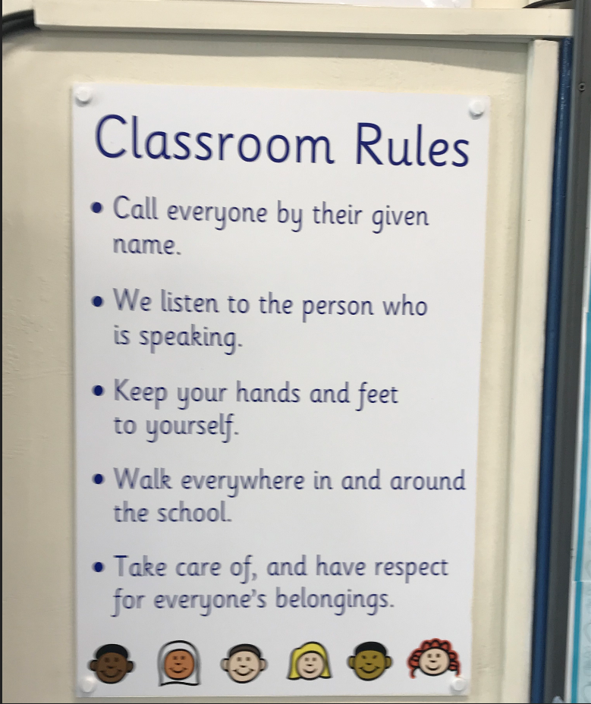

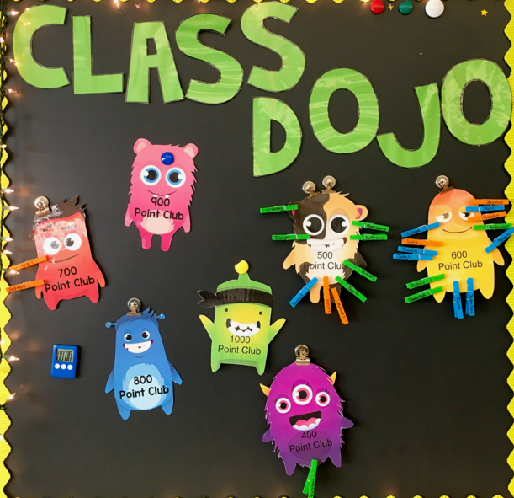

**Behaviour Reflection Sheet for KS1 Children**

Behaviour Reflection Sheet for KS2 Children

**5 Point Scale**

